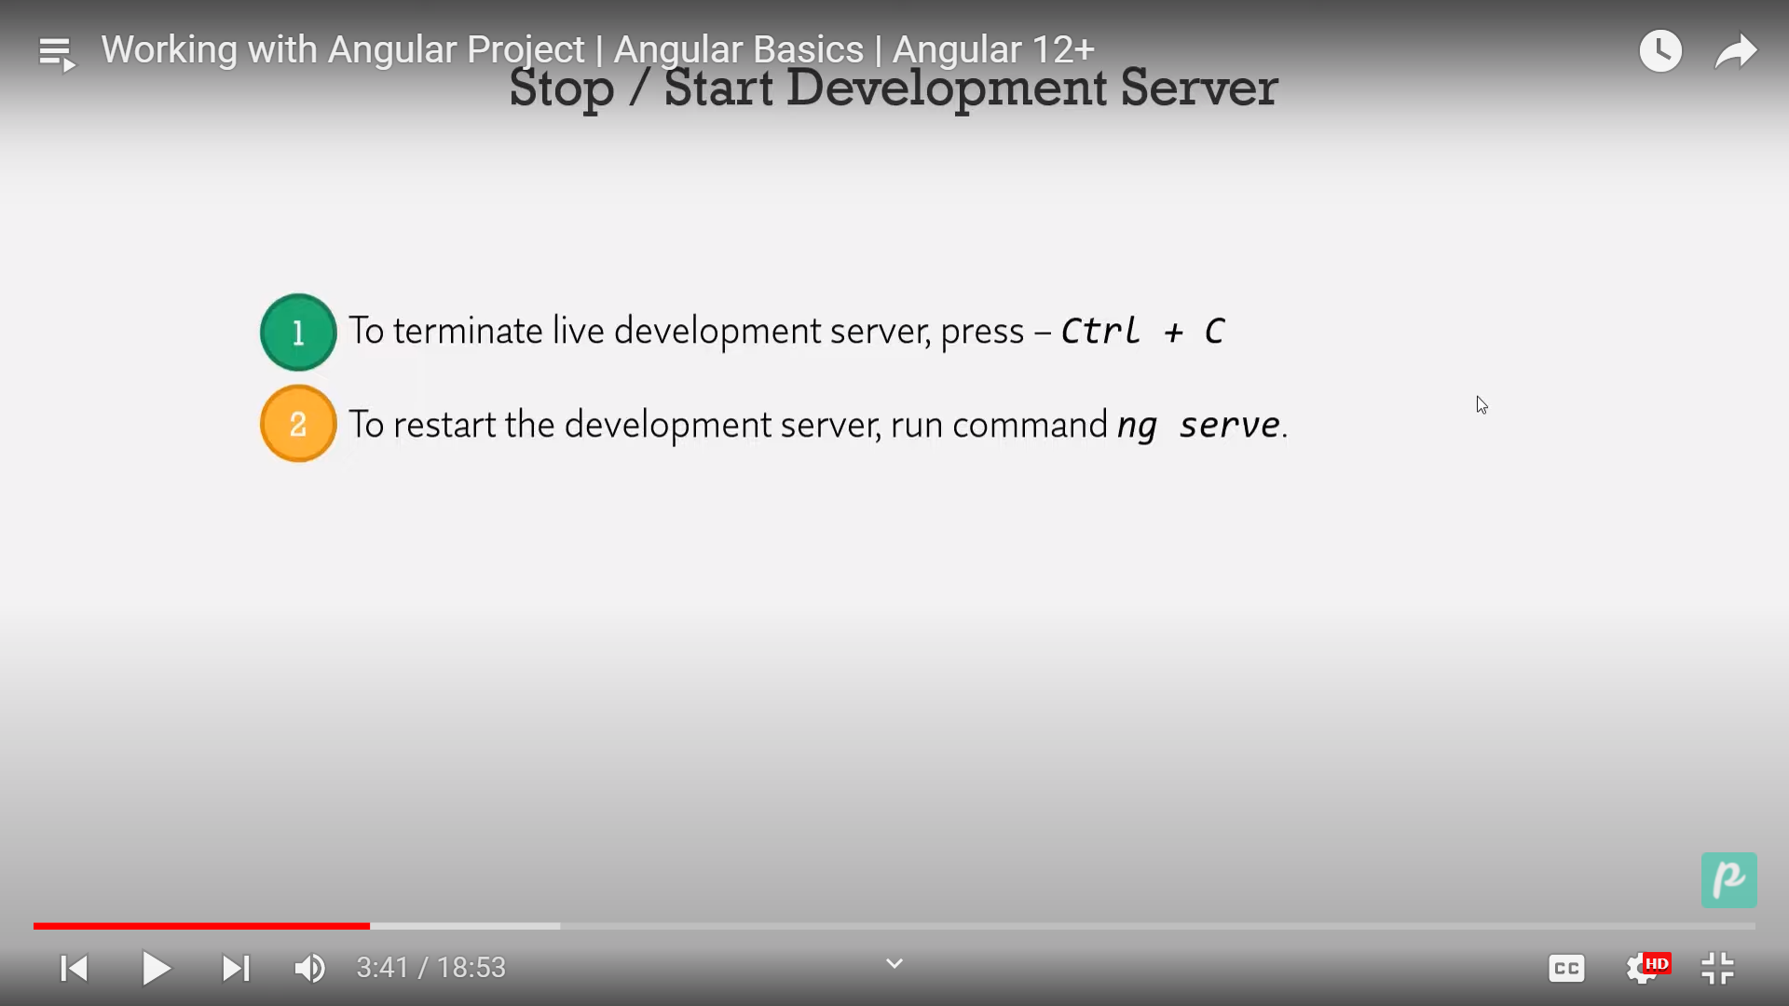

Step1: Go to the App.html and write your code

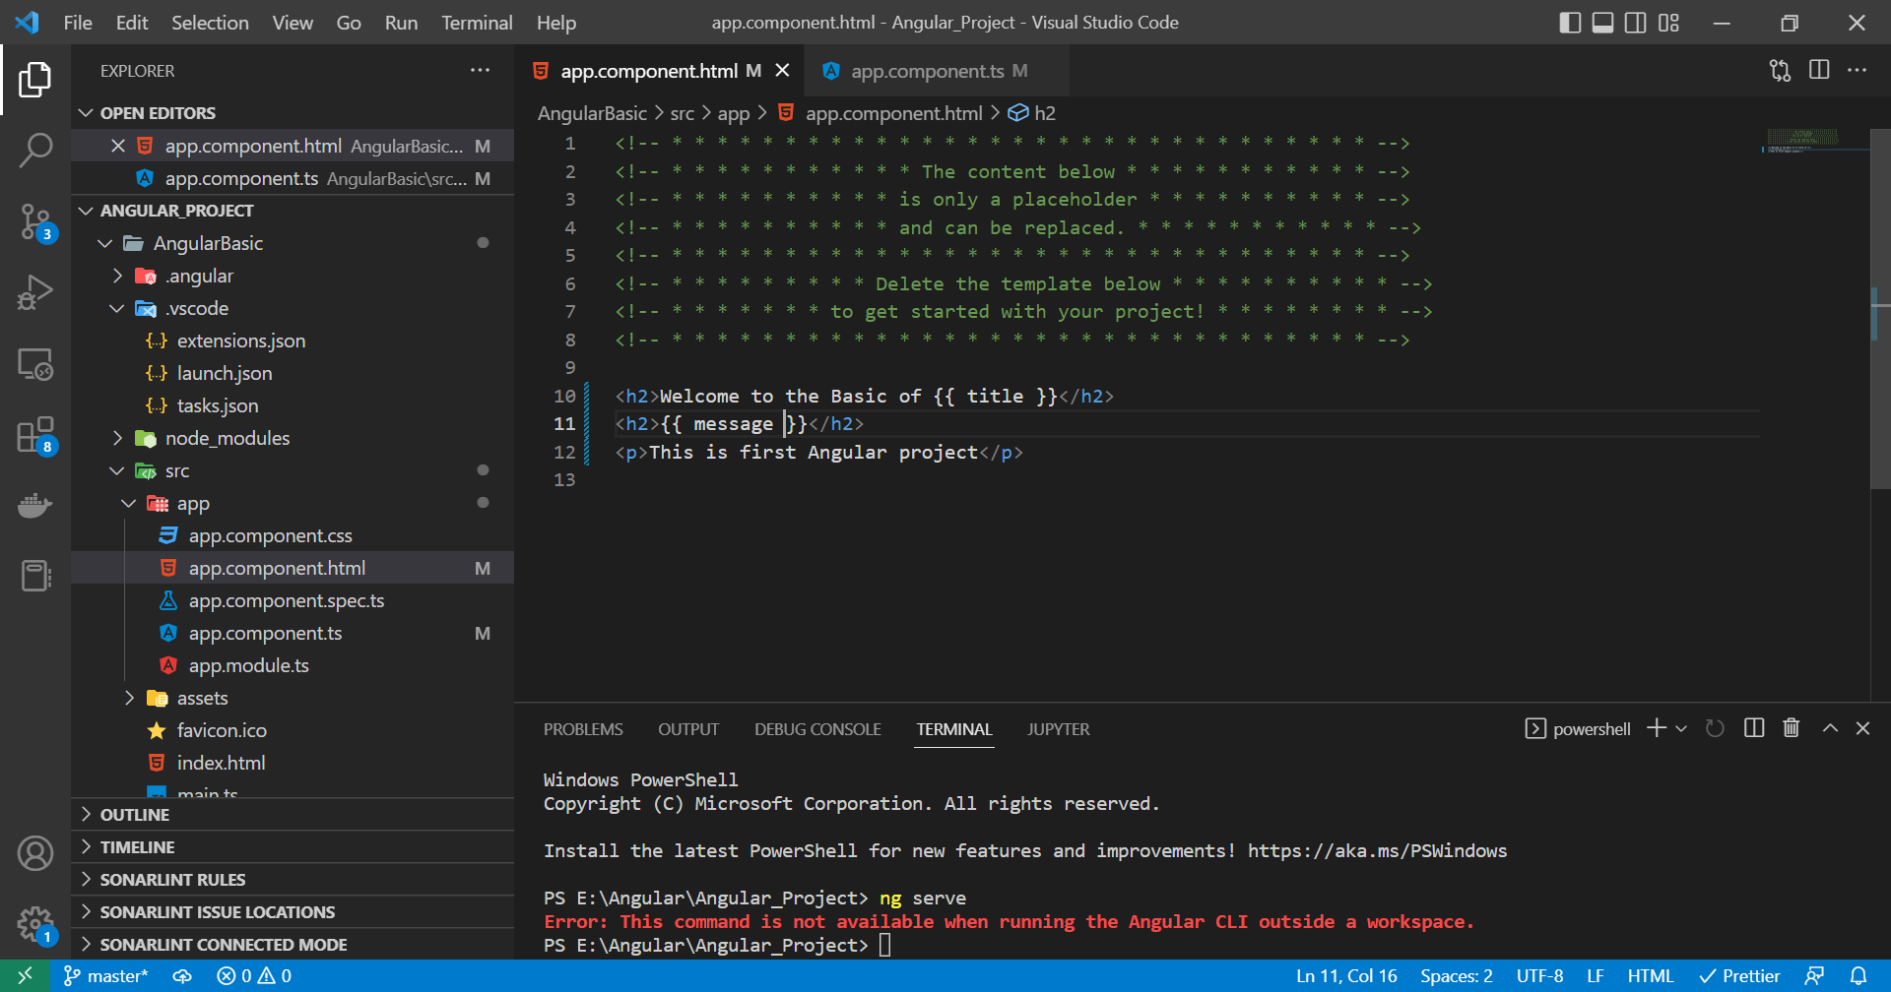

Step 2: Click on app component and write title and message

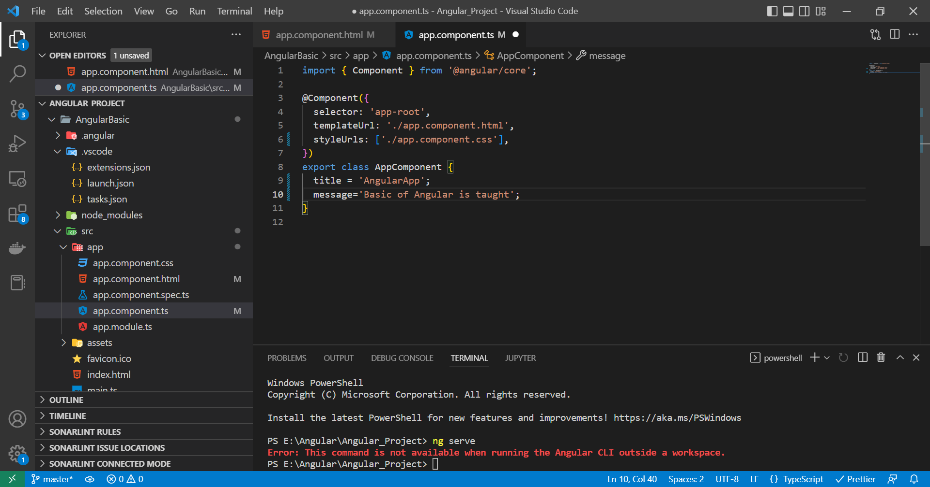

Step3: Output is

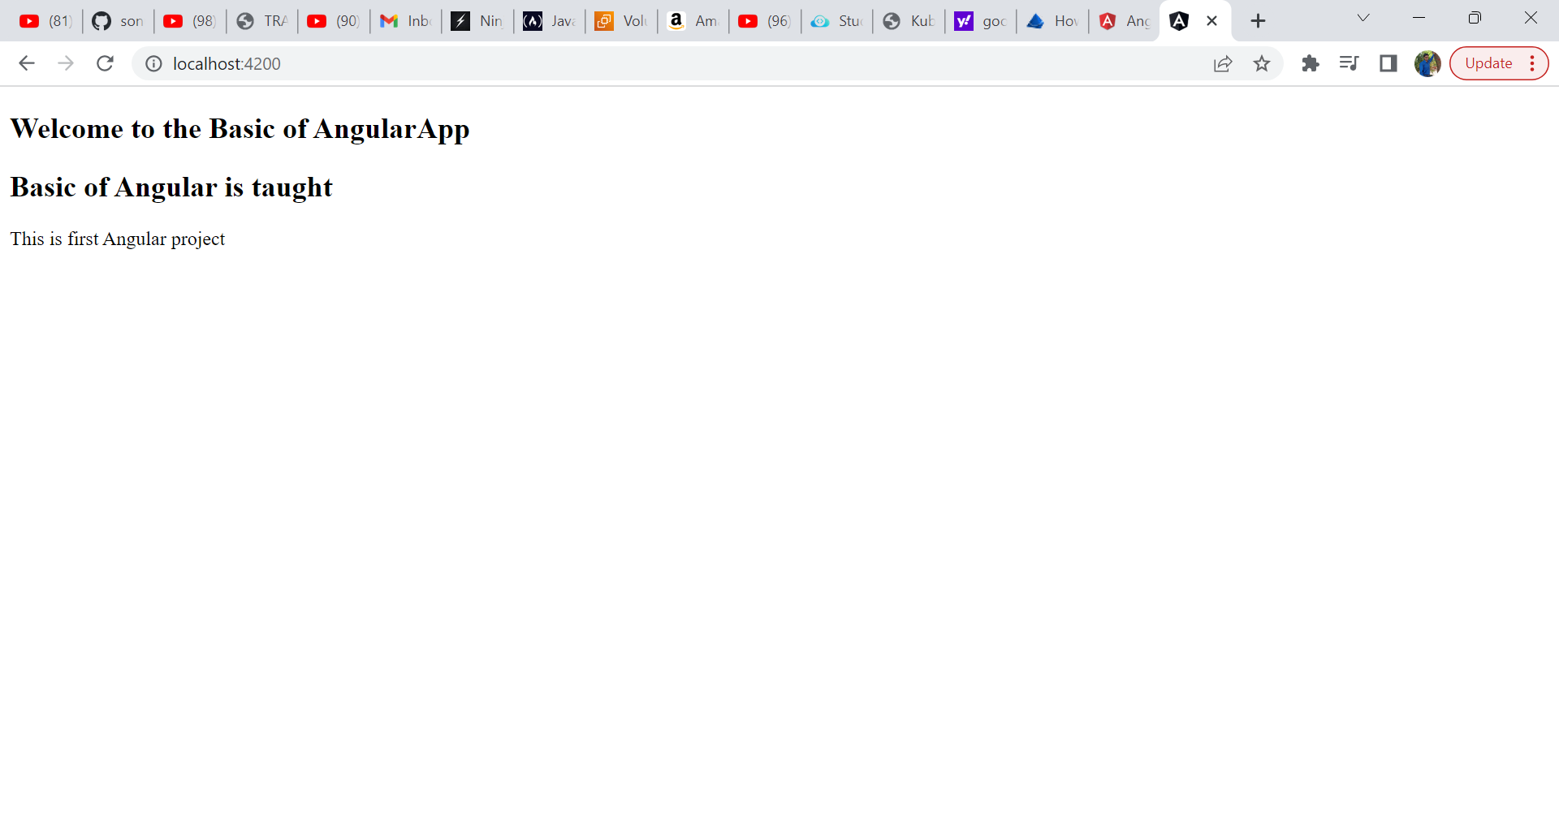

App component required 4 files html,css typescript file and test file

Working of Angular

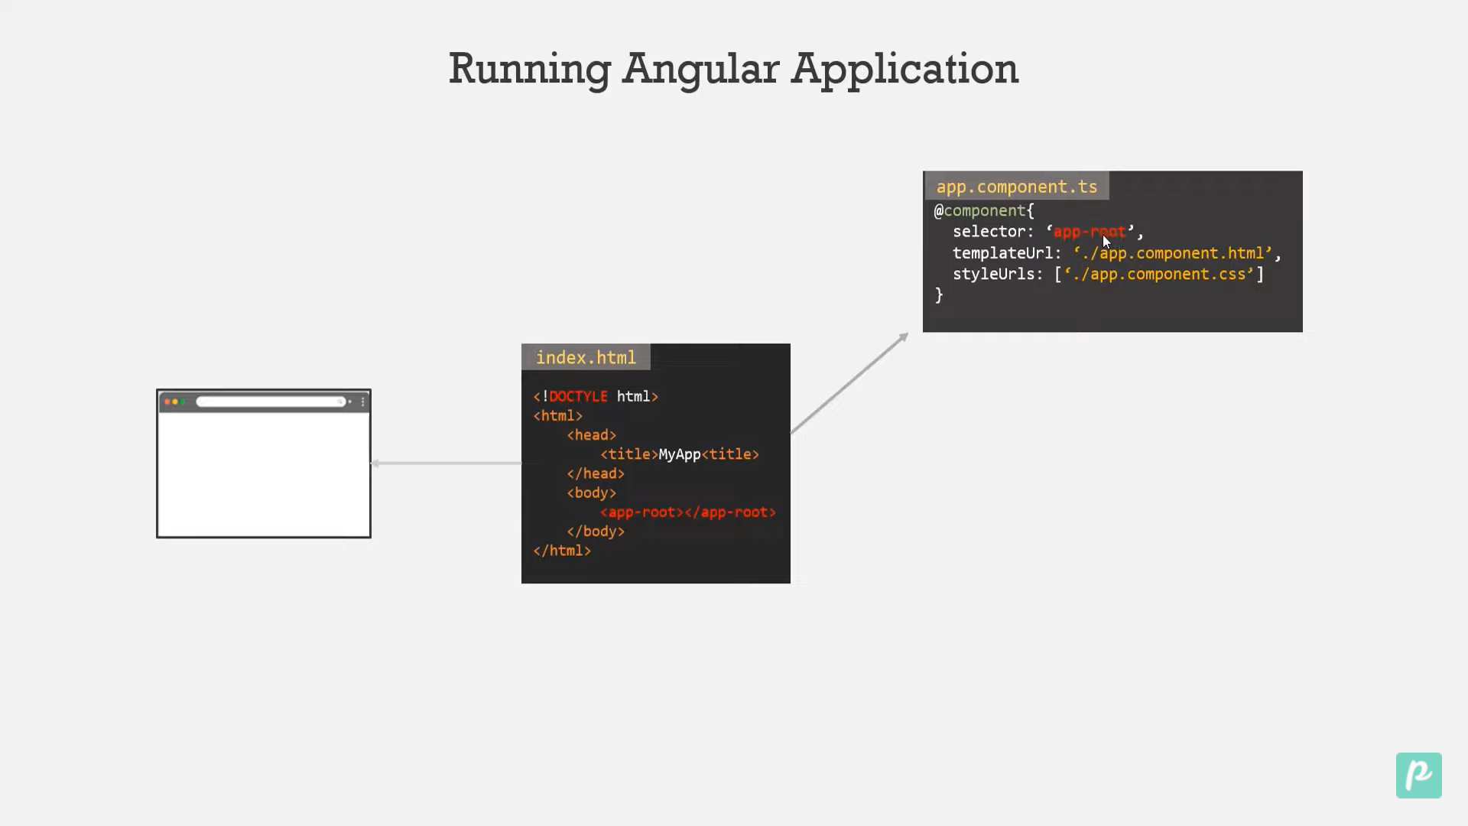

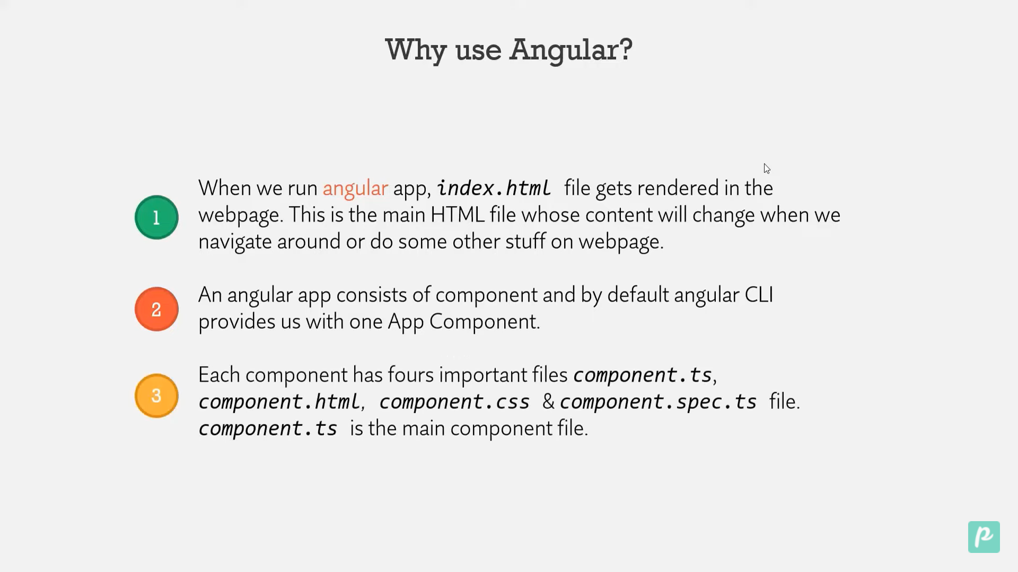

Html file is view template

Execution of angular

Step1: when we run angular project first file executed is main.ts file.This contain Appmodule so angular will load appmodule.

Step2: Appmodule is present in app folder and inside app.modules.ts

Step3:It contain bootstrap which contain the component. The appcomponent is present in app.component.ts file

Step4: Then index.html file is loaded in the browserand app-component is replaced with view component.

Step5: angular/cli inject the scritp file